**Custom picklist with searchable bar**

**Prepared By**

Florentino Aryo Widyantoro,

Technical Consultant

Result Example:

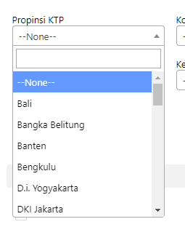

How to:

1. Download select2 javascript plugins from <https://github.com/select2/select2/tags>
2. Upload to SF as static resource
3. Detailed code can be found here: <https://github.com/FlorentAryo/SF-Rep/tree/main/Custom%20picklist%20with%20searchable%20bar>

References:

https://select2.org/